Experiment 10

Aim – Study of SWI Prolog installation and Execute some facts and rules

Steps to install Prolog

Step 1: Go to website <https://www.swi-prolog.org/download/stable>.

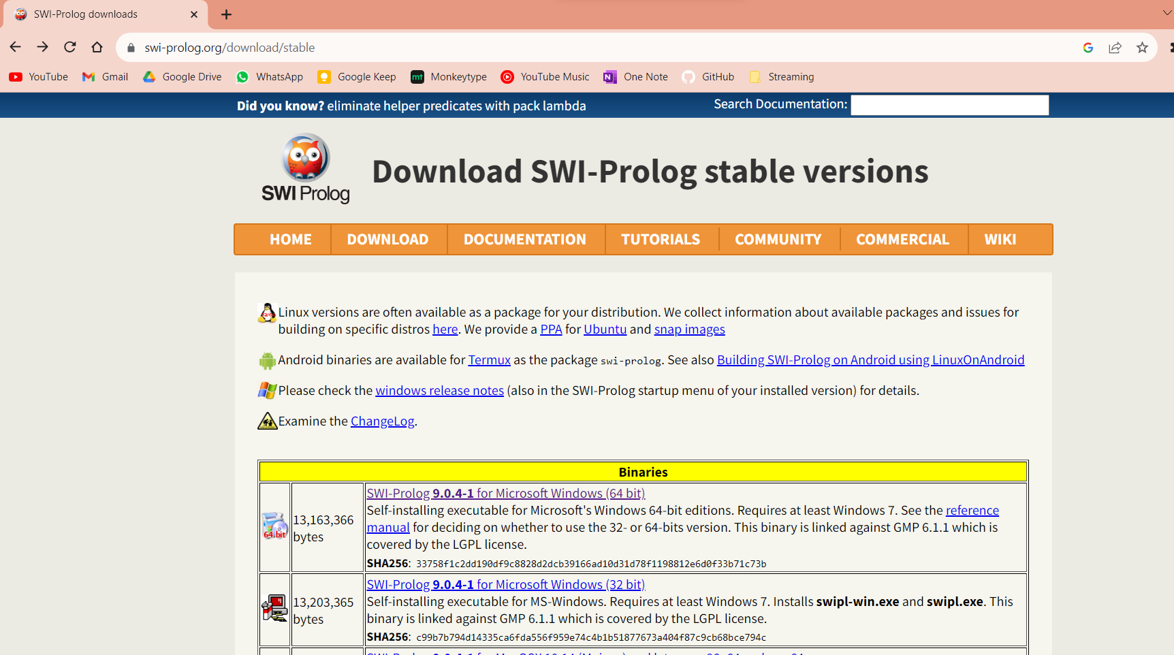

Step 2: Download the windows version of SWI Prolog

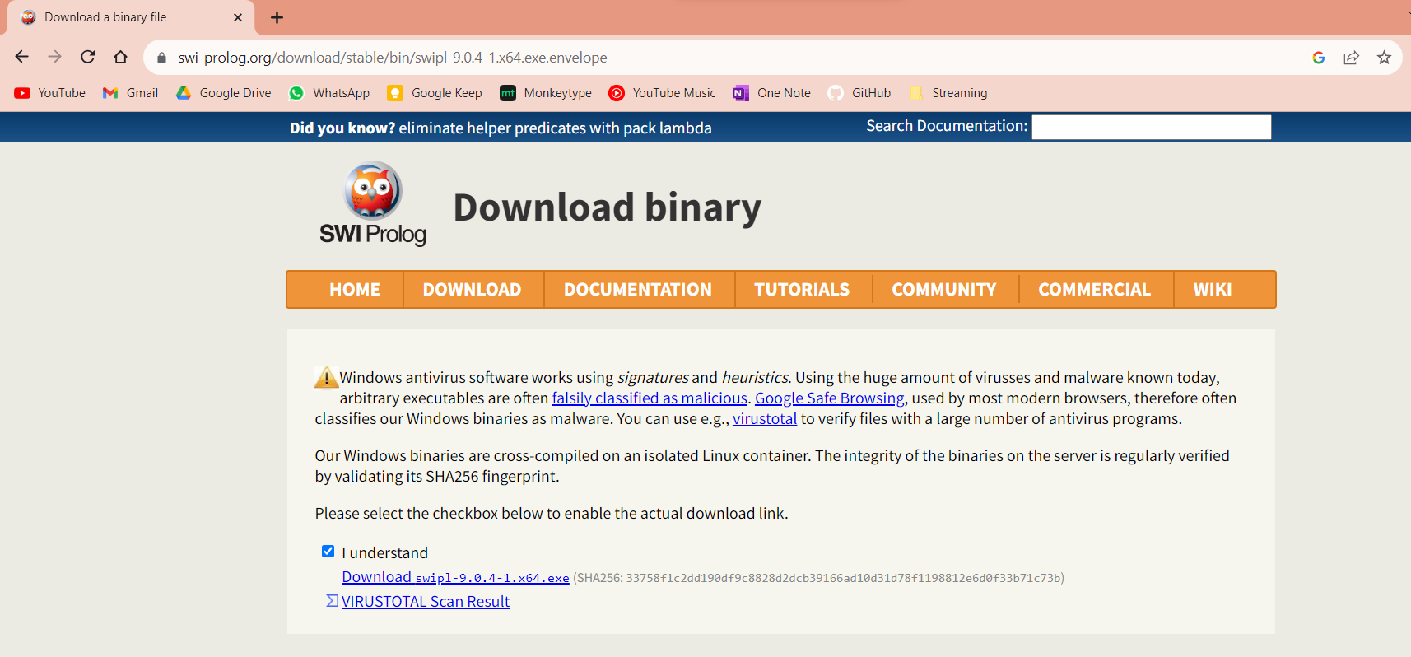

Step 3: Install the program by given the administrator permission to installer

Step 4: Click Next to proceed with installation agree to the terms and condtions

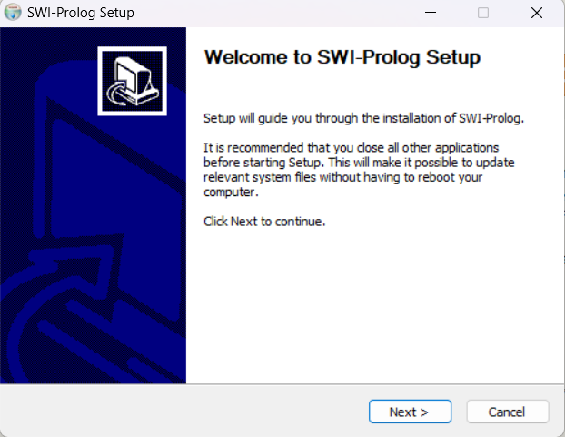

Step 5: Select the second option to add the path of the program

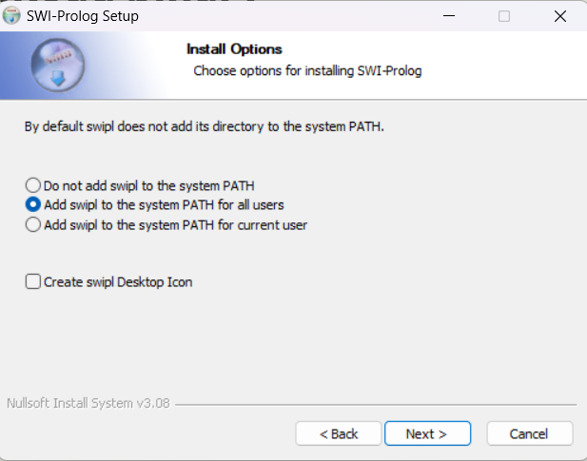

Step 6: Finish the install by clicking finish button and your SWI Prolog interpreter is ready to use

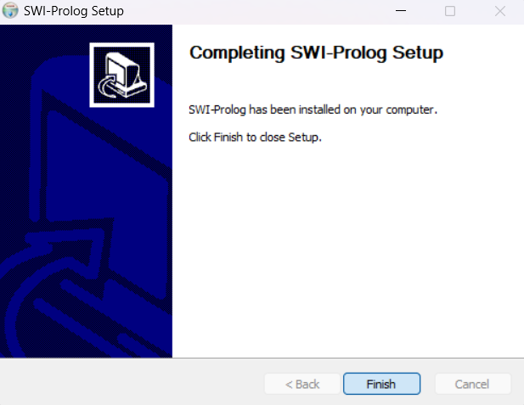

Writing Facts and Rule in Prolog

To write facts and rules in prolog you first have to create a prolog source file with .pl extension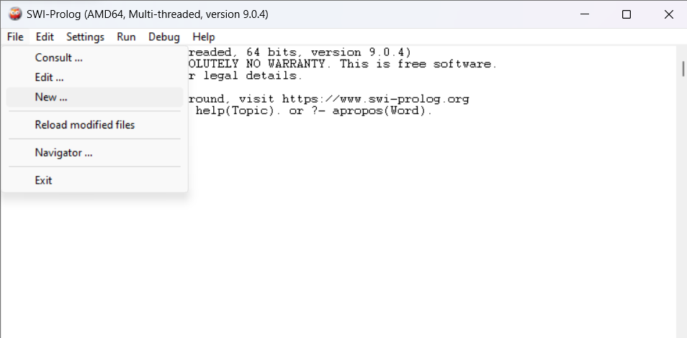

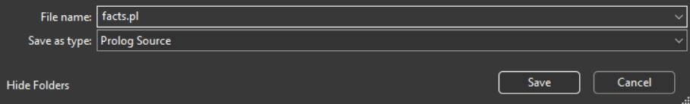

Write you facts and rules in that file and the click on compile > compile buffer to compile the file

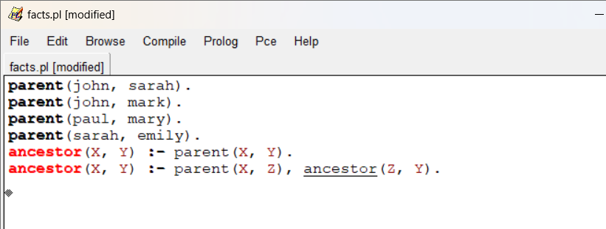

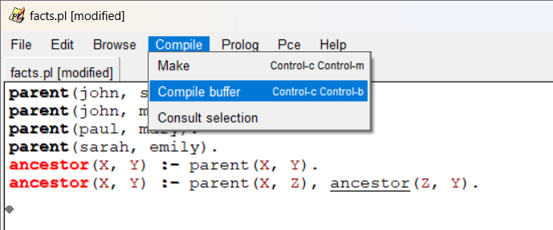

After this you can execute you queries in main window

